SQL Exercise 1

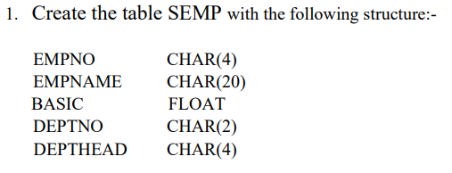

create table SEMP

(

EMPNO char(4),

EMPNAME char(20),

BASIC float,

DEPTNO char(2),

DEPTHEAD char(4)

);

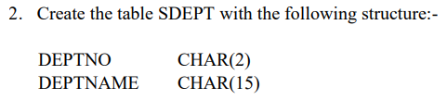

create table SDEPT

(

DEPTNO char(2),

DEPTNAME char(15)

);

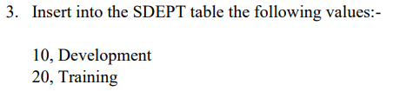

insert into SDEPT values

('10','Development'),

('20','Training');

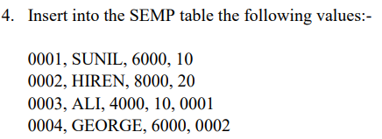

insert into SEMP values

('0001','SUNIL',6000,'10',null),

('0002','HIREN',8000,'20',null),

('0003','ALI',4000,'10','0001'),

('0004','GEORGE',6000,null,'0002');

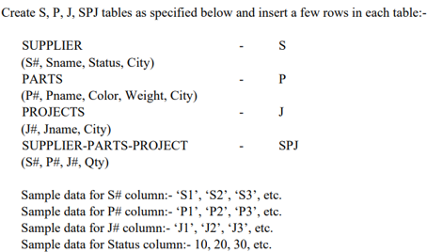



select * from s;



select `s#`,sname from s;



select pname,color from p

where city='london';



select sname from s

where city='london';



select sname from s

where city='athens' or city='paris';



select Jname from J

where city='athens';



select Pname from P

where weight<=14 and weight>=12;



select sname from s

where status >= 20;



select sname from s

where city != 'london';



select sname from s

where city is not null;



select pname,weight In_Gram,

weight*1000 In_Milligram,

weight/1000 In_KG from p;